Text Analytics Platform

KARText Analyzer

By ,Kartikeya Misra BTech (IT ‘2014-2018’) IET Lucknow

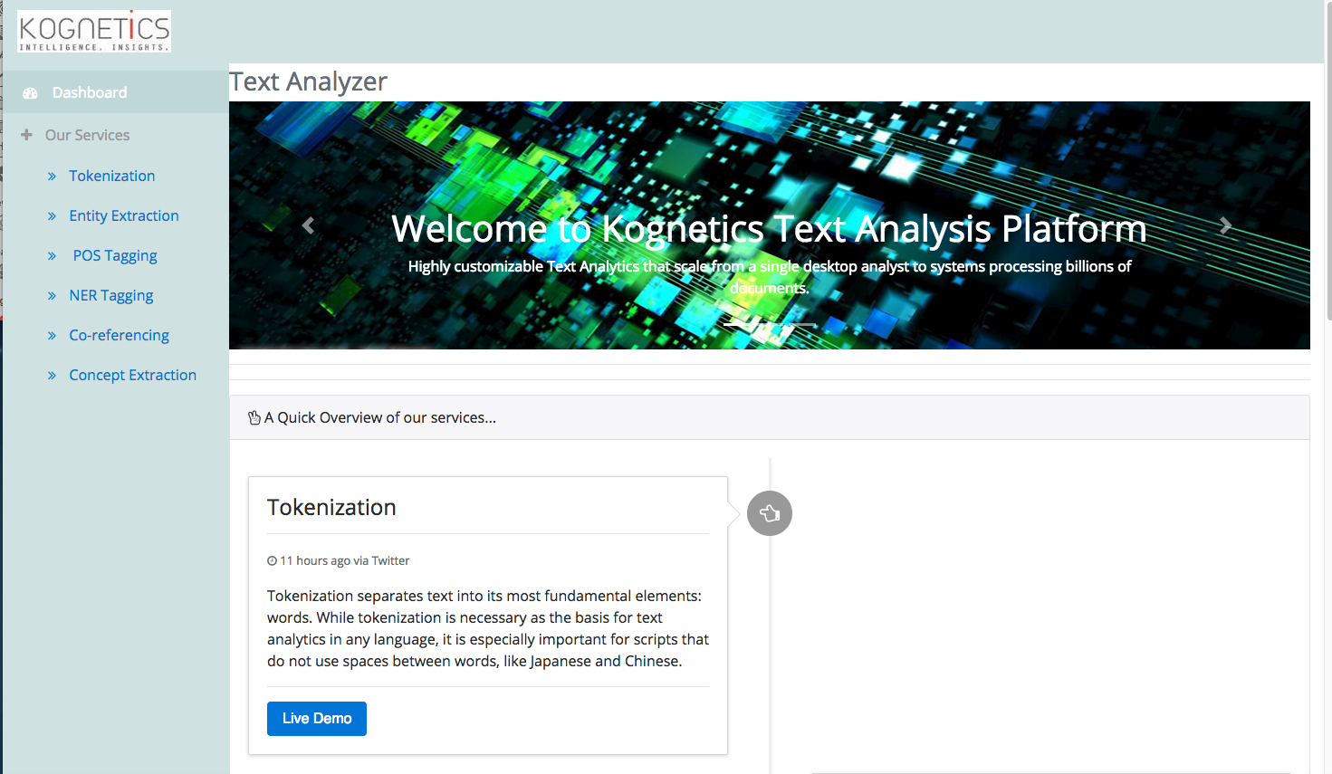

# Requirements

Client Side

* Nodejs and Angular-cli
* Angular 4
* Bootstrap 4
* Font Awesome Icons

Server Side

* Python 2.7 with Virtualenv
* Django
* Django Rest Framework

## Directory Structure and Environment Setup

The main project Directory i.e. ‘Kognetics’ contains ‘Textanalytics’ sub-directory along with Python Virtual Environment folder, in this directory the venv should be activated.

$ cd kartext/textanalytics

$ source env/bin/activate

In ‘Textanalytics’ sub-directory there are two sub-directories:

* CLIENT- contains Angular 4 project for client side or front end. To host it,on URL [http://localhost:4200](http://172.20.10.140:4200/)

$ cd kognetics/textanalytics/client

$ npm start

* SERVER- contains Django project for server side Rest APIs and backend. To host it,on URL [http://localhost:8000](http://127.0.0.1:8000/)

$ cd kognetics/textanalytics

$ python server/manage.py runserver

## For Development

All the server side functionality is simple and is done with simple rest api modules in server sub-directory there is also a config folder which contains ‘settings.py’ file which is the main controller of Django project.

In client sub directory, the main project front is in src/app, in app directory,

* ‘Login’, ‘Not Found’, ‘Signup’ are three modules which are currently not in use, but still there for future use.
* ‘Assets’ folder contains il8n folder which has en.json file for webpage language translations and ‘images’ folder contains images on the webpage and logo .
* ‘environments’ folder contains default env files required at the time of build or production.
* ‘Styles’ folder contains main files for global styling of almost all components, i.e. main bootstrap , css and scss config files are here.
* ‘Shared’ folder has shared utilities of both the view components(shared/components/header & shared/components/sidebar) as well as controllers(pipes, auth-guard and page-header etc.) .
* ‘Layout’ sub-directory is actually the main source of different views of different services and Dashboard etc.

**Routing:**

Routing of whole client side project is done according to directory-hierarchy i.e. main project app directory has main ‘app-routing.module.ts’ file similarly layout sub directory has layout-‘routing.module.ts’ ,similarly all the sub modules in layout sub-directory have their own ‘*-routng.module.ts’ alongside respective controllers i.e. ‘*.component.ts’

## Services

The Kogntics Text analyzer provides following services text analysis :

* Tokenization
* Entity Extraction
* POS Tagging
* NER Tagging
* Co-Refferencing
* Concept Extraction

Note: This project uses NLTK i.e. Natural Language Toolkit which is copyrighted by Bird, Steven, Edward Loper and Ewan Klein (2009), Natural Language Processing with Python. O’Reilly Media Inc.

Tokenization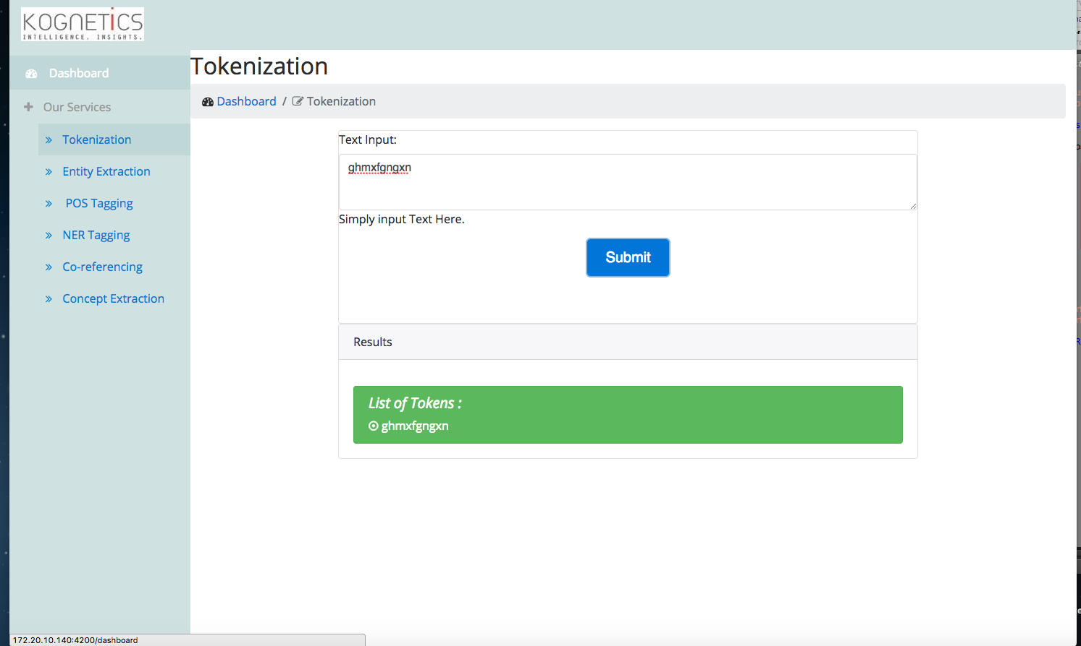

Entity Extraction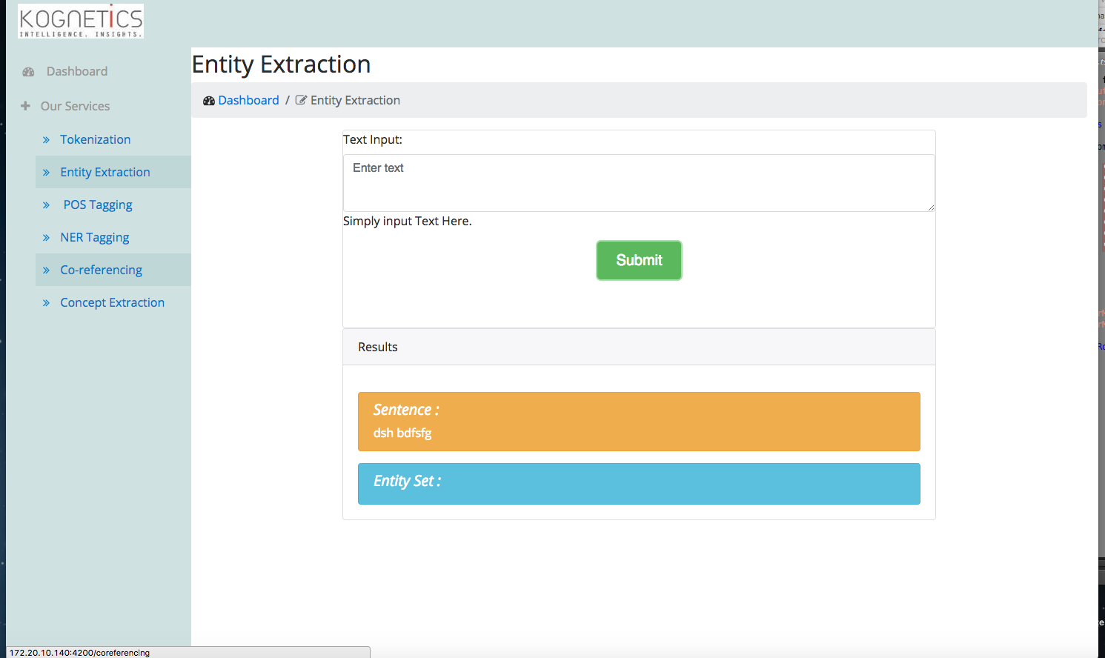

POS Tagging

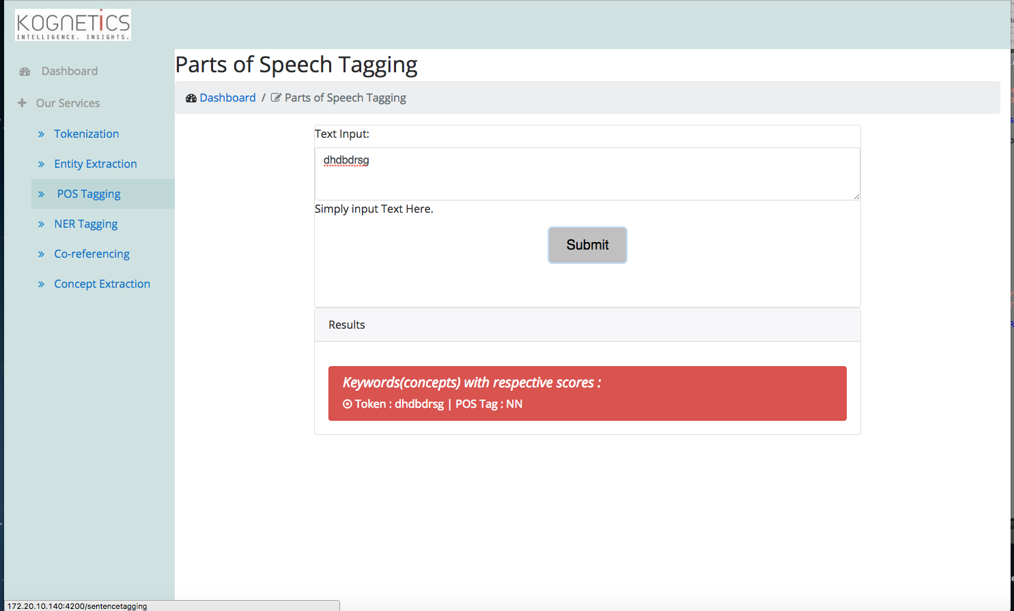

NER Tagging

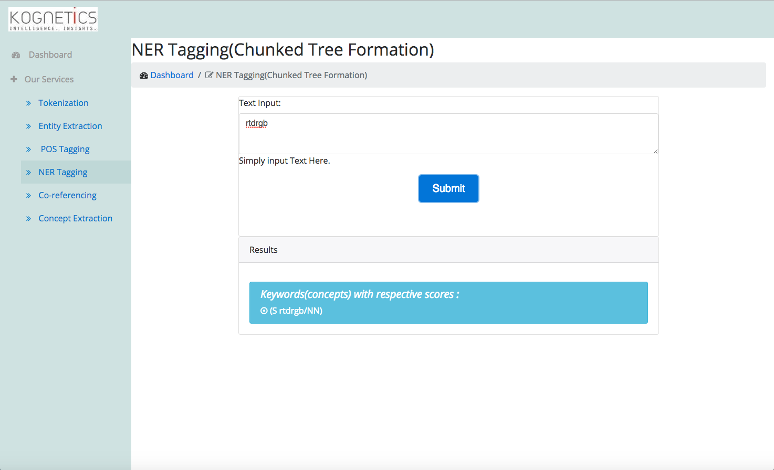

Co Referencing

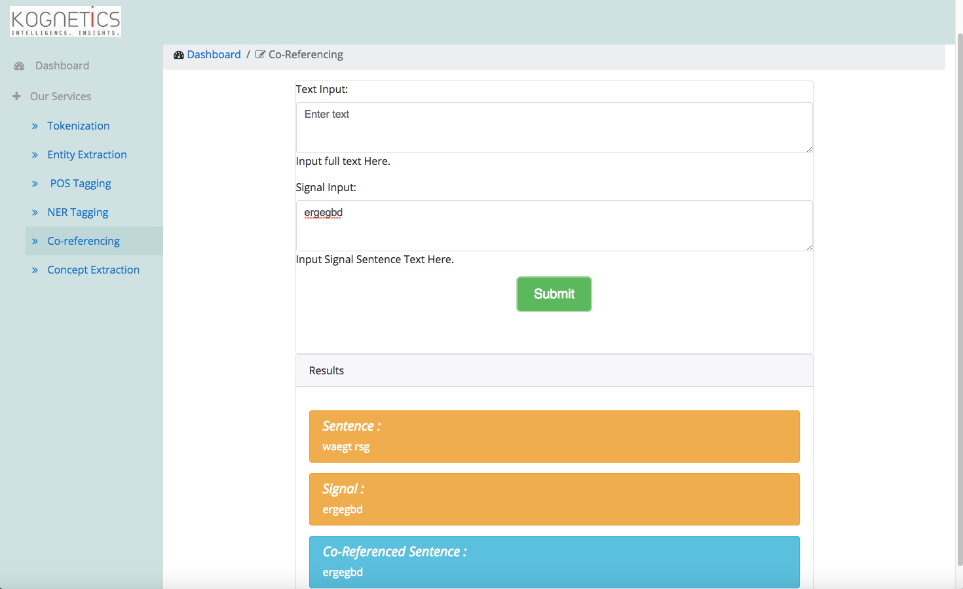

Concept-Extraction

